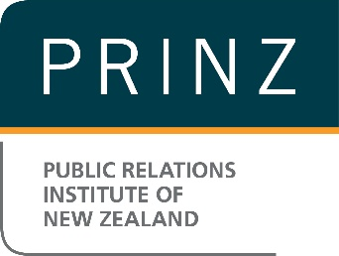
PRINZ Professional Development Plan

Name:

Job title:

Organisation:

Date:

Step 1: Review your previous professional development to assess where you are now

What continuing professional development did I undertake last year?

Did I meet or exceed my expectation on my professional development? If not, why?

If you didn’t undertake any professional development programmes last year, now is the perfect time to start your planning!

Step 2: Identify your strengths and areas for further development
What are my strengths?

What are my areas for further development?

Step 3: Plan your career goals.
While focussing on areas that you can improve on, don’t forget to think about how you can further develop your strengths as well.

What are my long-term goals? | What are my specific goals? | What are the key skills needed? | What skills do I need to work on?

Step 4: Gather information and explore opportunities to achieve your specific goals
What training sessions through PRINZ and/or other channels/providers do I plan to attend?

Check out PRINZ Education & Events Calendar.

Am I going to undertake any formal education, e.g. APR (Accreditation in Public Relations) or Tertiary papers?

Step 5: Plan your timeline

Month | Professional development focus | What actions am I going to take?
January
February
March
April
May
June
July
August
September
October
November
December

Step 6: Keep track of your progress and continue to revise your professional development plan
Your professional development plan will never be final or complete. Follow the plan as closely as possible, but don’t be afraid to revise or update it as you go – it’s all part of the learning process.
When am I going to review my progress? (*Remember to add the dates to your calendar.)

If you have any queries about the professional development Plan, please email alice@prinz.org.nz.

